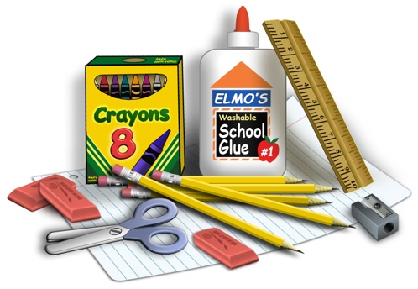

Pre-K Supplies

Your child will need a labeled school bag and a folder daily. (Please be sure the folder has bottom pockets, and the school bag must be large enough to fit the folder nicely.)

- A small individual picture of your child for their cubby and a family photo.

- A complete extra set of clothes: shirt, pants, underwear, and socks. (Labeled in a Ziploc bag).

We accept donations of the following items:
- boxes of tissues
- paper towels
- liquid hand soap,
- hand sanitizer
- zip lock bags (snack, sandwich, or gallon size)
- copy paper
- tubs of baby wipes
- Lysol/Clorox Wipes

